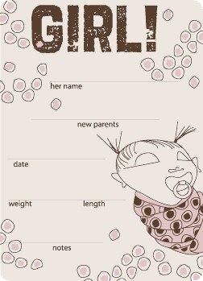

Lucy Belle

Joe & Mary

Sept. 15, 5:10 am

6 lbs. 7oz 21 in

Big Feet!

