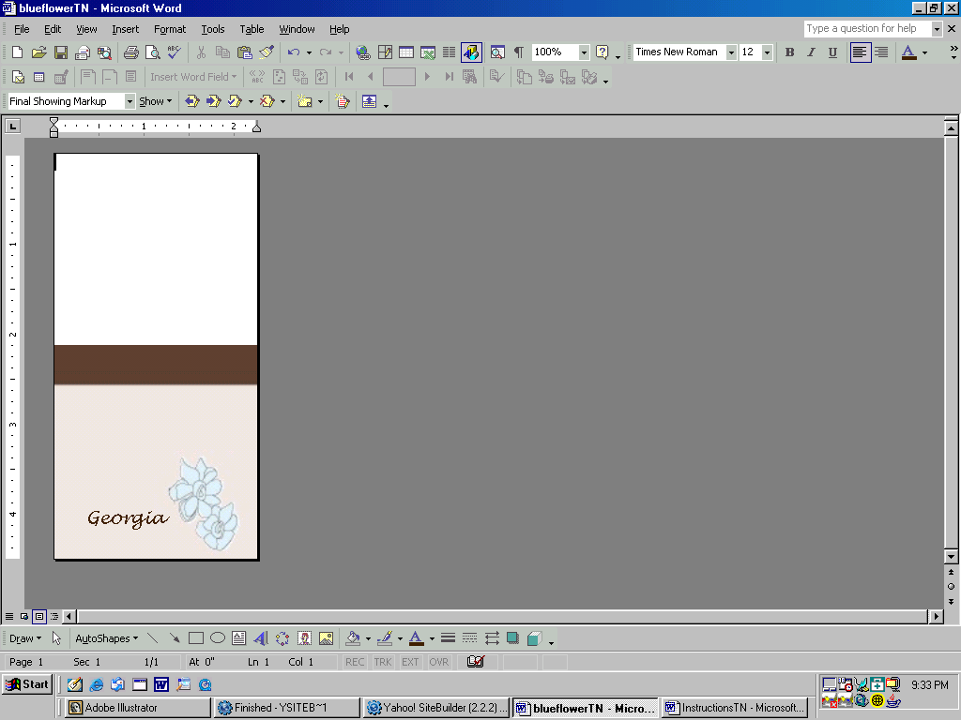
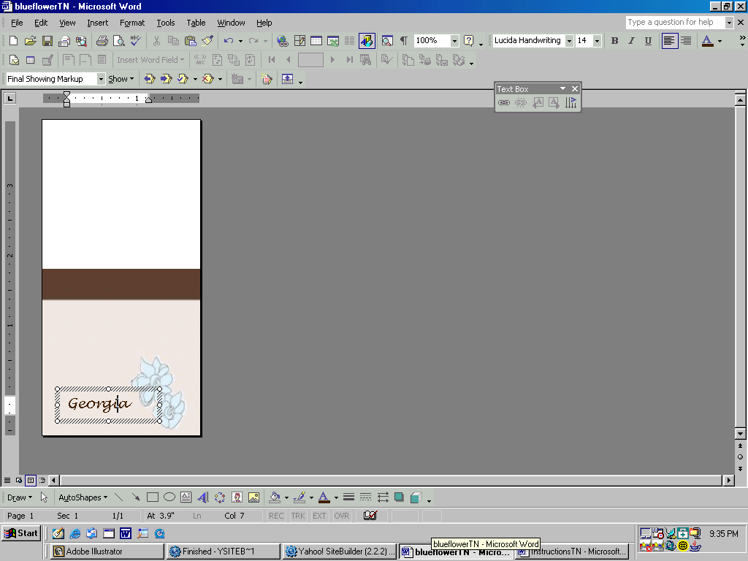

Step 1

Select the text by clicking on the type.

Type the name & table number.

Note: Change the font and font size for a different look. Add additional lines of text by copying the text box.
(Select the Box then CRTL+C)

Step 2

Adjust the placement of the text box using the arrows on the keyboard or the mouse.

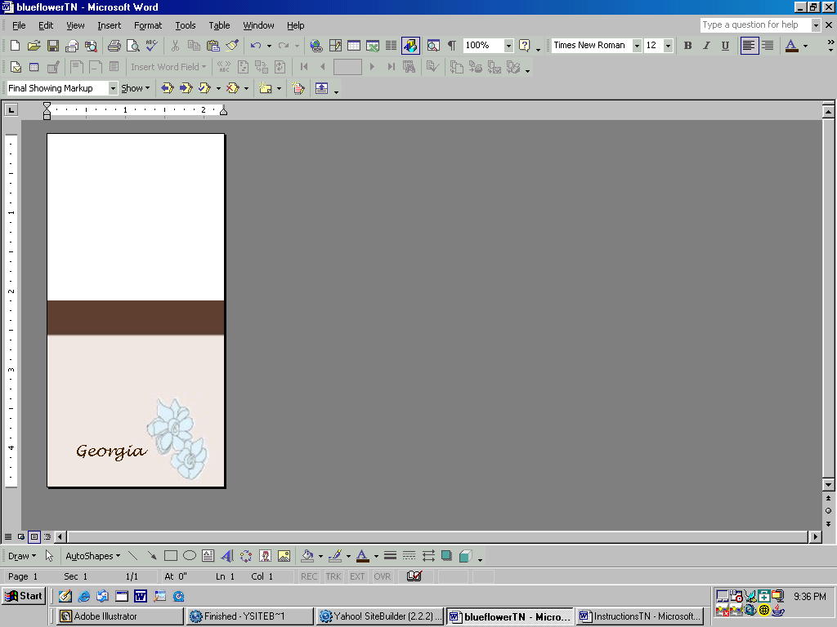
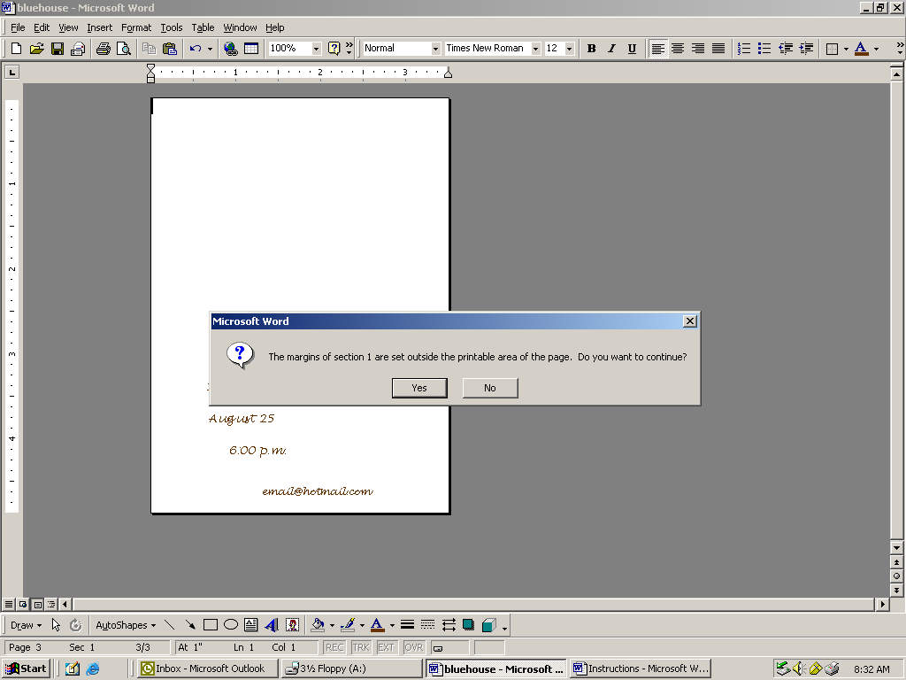

Step 3

Delete the image by clicking the blank space and hitting delete on the keyboard.

Step 4

First cut a piece of paper to the size of the table number. (2.25 x 4.5)

Adjust the paper stop on the printer to the same size as the paper.

Print the document. After clicking OK, a message will appear. Click yes.

Print a test page.

After printing a test page unfold the table number and print the first side and then flip the table number and print a second time.

