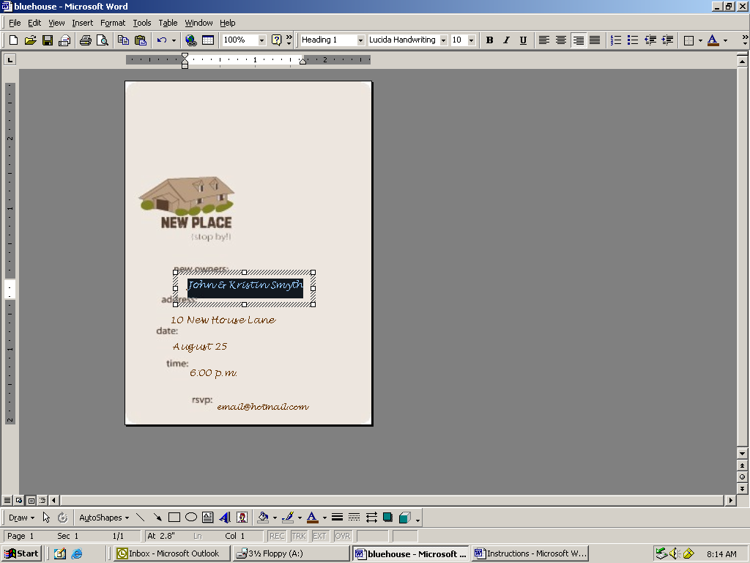
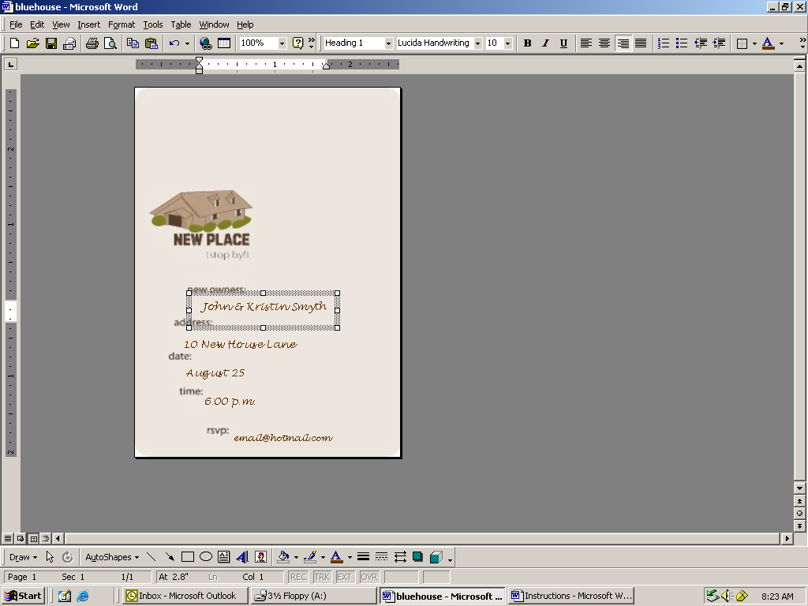

Step 1

Select the text by clicking on the type.

Type the party details on each line.

Note: Change the font and font size for a different look. Add additional lines of text by copying the text box.
(Select the Box then CRTL+C)

Step 2

Adjust the placement of the text box using the arrows on the keyboard or the mouse.

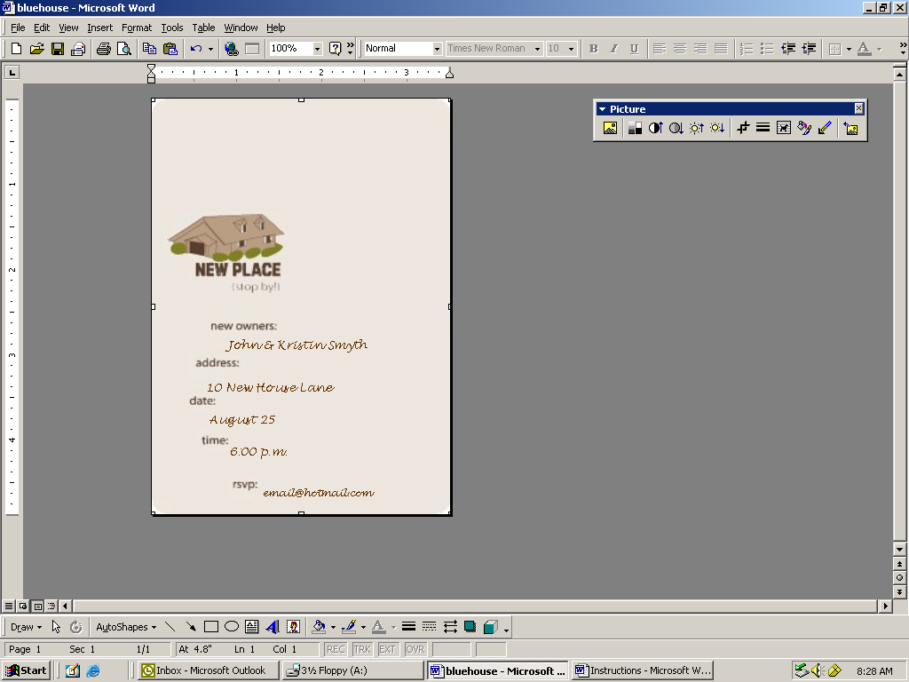
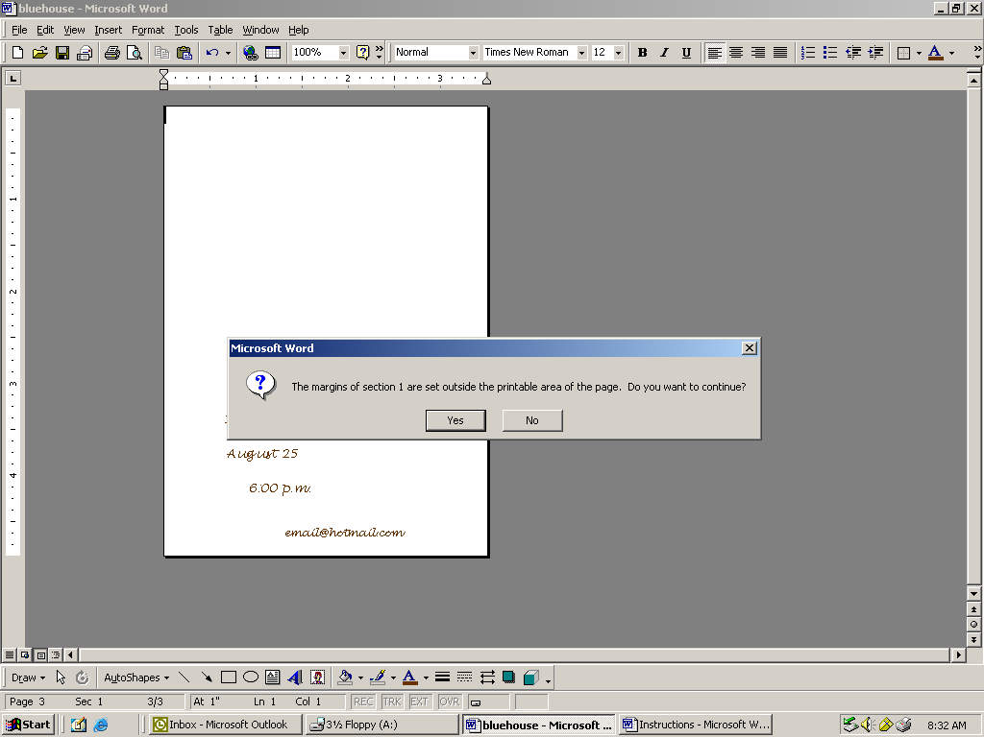

Step 3

Delete the image by clicking the blank space and hitting delete on the keyboard.

Step 4

First cut a piece of paper to the size of the invitation.
3.5 x 4.875 (Vertical)
4.875 x 3.5 (Horizontal)

Adjust the paper stop on the printer to the same size as the paper.

Print the document. After clicking OK, a message will appear. Click yes.

The test page will indicate whether the invitation will be put into the printer upside down or inserted right side up.

Once the orientation is determined, you are ready to print the invitations!

